## Introduction

## Material and methods

### Contamination of biota by metals and organohalogen compounds

#### Data source

Concentrations of various contaminants were measured in bivalves collected from three major French estuaries (Gironde, Loire, and Seine) over periods ranging from 1979 to 2024, as part of the ROCCHMV monitoring program. The Pacific oysters (*Crassostrea gigas*) was studied in the Gironde estuary, two species of mussels (*Mytilus edulis and Mytilus galloprovincialis*) were studied in the Seine estuary. In the Loire estuary mussels were studied and from 2017 oysters were also studied in parallel. Sampling was conducted in the most saline zones of each estuary, near their respective mouths.

#### Data transformations

When multiple measurements were taken on the same year, the yearly average value was used. Values under limit of detection were replaced by zero value. The similarity of bioaccumulation potential of mussels and oysters was estimated through the difference in their contamination level. When a difference was detected, like it is known for several metals, all concentrations were expressed in “equivalent mussels” using an oyster-to-mussel conversion factor. The conversion factor was estimated for each compound through the ratio of their median contamination on the basis of 7 years of parallel measurements in oysters and mussels in the Loire estuary (2017-2024).

Table 1 - Oyster-to-mussel conversion factor for metals (in µg/g dw).

|  |  |  |  |  |  |  |  |  |  |
| --- | --- | --- | --- | --- | --- | --- | --- | --- | --- |
| Metal | Mercury | Cadmium | Lead | Zinc | Copper | Nickel | Vanadium | Silver | Chromium |
| Factor | 0.634 | 0.718 | 0.898 | 0.050 | 0.036 | 2.464 | 1.0708 | 0.005 | 0.945 |

#### Data analysis

The most recent trend was estimated from time series data using the segmented function, from the package of the same name. This method allows the identification of one or more breakpoints in time series data and fits a separate linear regression for each segment. For each estuary and each compound, the significance of the slope of the last segmented was statistically tested to conclude about the last observed trend. The long term trend was estimated using a Kruskal-Wallis rank sum test (kruskal.test from the package {stats}) from contamination data during the first and last 5-year periods for the compounds with over 20 years of measurements, and 2 years periods for the others. To compare contamination levels between estuaries, median values was computed for this last period.

#### Studied compounds

Only a selection of chemicals was retained and listed in Table 1 if they fulfilled one of these statements:

* the ones most concerned by European to national human health and ecotoxicological thresholds in biota (European Commission, 2013 for European Union; legifrance.gouv, 2023 for France; OSPAR, 2023 for countries of Atlantic N-E),
* the metals historically polluting or emergent in at least one of the studied estuaries (Ifremer, 2018, 2024, 2025)
* the ones that have been over the limit of detection in biota in the present dataset.

The complete list of monitored contaminant as well as their origin, use and sources can be found on “Envlit” website from Ifremer (<https://envlit.ifremer.fr/Surveillance-du-littoral/Contaminants-chimiques/Contaminants-suivis>). Their main sources and ecotoxicological effects have been synthetized from (Ifremer, 2021). Legislative threshold considered along with their origin and type of matrix considered are presented in Table 1.

Table 1 – Characteristics and thresholds in biota for the selected contaminants.  
Threshold type related to human health: QS(HH) (EU Quality Standard for Human Health), EC MPC (European Commission maximum permissible concentrations).   
Threshold types related to ecotoxicology: EQS (EU Ecological Quality Standard), EAC (Environmental Assessment Criteria: North-Est Atlantic OSPAR equivalent of EQS), BAC (Background assessment Concentration: North-Est Atlantic OSPAR for 'close to background’ in natural conditions) NQE (Norme de Qualité Environnementale: French equivalent of EQS), VGE (Valeurs Guide Environnementales: French equivalent of EQS for bivalves).   
Matrix abbreviations: f.: fish, c: crustaceans, m: molluscs, b: bivalves, g: gastropods.   
(E) concentration in Mytilus edulis in wet weight based on a 16.4% dry weight in soft body (OSPAR, 2023d)  
(G) concentration in Crassostrea gigas in wet weight based on a 18.0% dry weight in soft body (OSPAR, 2023d)  
(*) Refers to the following compounds: 7 polychlorinated dibenzo-p-dioxins (PCDDs): 2,3,7,8-T4CDD, 1,2,3,7,8-P5CDD, 1,2,3,4,7,8- H6CDD, 1,2,3,6,7,8-H6CDD, 1,2,3,7,8,9-H6CDD, 1,2,3,4,6,7,8-H7CDD, 1,2,3,4,6,7,8,9-O8CDD (OCDD); 10 polychlorinated dibenzofurans (PCDFs): 2,3,7,8-T4CDF, 1,2,3,7,8-P5CDF, 2,3,4,7,8-P5CDF , 1,2,3,4,7,8-H6CDF, 1,2,3,6,7,8-H6CDF, 1,2,3,7,8,9-H6CDF, 2,3,4,6,7,8-H6CDF, 1,2,3,4,6,7,8-H7CDF, 1,2,3,4,7,8,9-H7CDF, 1,2,3,4,6,7,8,9-O8CDF (OCDF) ; 12 dioxin-like polychlorinated biphenyls (PCB-DL): PCB 77, PCB 81, PCB 105, PCB 114, PCB 118, PCB 123, PCB 126, PCB 156, PCB 157, PCB 167, PCB 169, PCB 189.  
(§) The threshold of 0.0065 ng/g TEQ refers to the weighted sum of compounds concentrations expressed in toxic equivalents (TEQ), using a multiplication factor known as the toxic equivalency factor (TEF according to the World Health Organization 2005). This factor reflects the toxicity of each compound relative to the reference dioxin (2,3,7,8-TCDD), which has a TEF of 1. The TEFs used, from the least to the most toxic, are: 3×10⁻⁵ for CB 105, 114, 118, 123, 156, 157, 167, and 189; 1×10⁻⁴ for CB 77; 3×10⁻⁴ for OCDD, OCDF, and CB 81; 3×10⁻² for CB 169; and 0.1 for CB 126.  
¤ long term evolution, last short term evolution, deviation from limit value (blue: [0-50%[, green: [50-100%[, yellow:[100-150%[, orange: [150-300%[, red: [300-500%[, black: > 500%)

|  |  |  |  |  |  |  |  |  |  |  |  |
| --- | --- | --- | --- | --- | --- | --- | --- | --- | --- | --- | --- |
|  |  |  |  |  |  |  |  |  | EVALUATION¤ | | |
| Family | Contaminant | Main Sources | Ecotoxicological Effects | Bioacc. | Time series | Threshold | Matrix | Type (source) | Gironde | Loire | Seine |
| Historically monitored heavy metals | Mercury (Hg) | Coal combustion, mining | Neurotoxicity, reproduction impairment | Very high | 1979-2024 | 500 ng/g ww | b | EC MPC (OSPAR, 2023a) | → → 🔵 | → → 🔵 | → → 🔵 |
| Cadmium (Cd) | Mining, batteries, pigments, electroplating | Kidney damage, growth inhibition | High | 1979-2024 | 1000 ng/g ww | b | EC MPC (OSPAR, 2023a) | ↓ → 🟠 | ↓ ↓ 🔵 | ↓ → 🔵 |
| **Lead (Pb)** | Leaded fuels (historical), paint, batteries | Neurological and developmental toxicity | High | 1979-2024 | 1500 ng/g ww | b | EC MPC (OSPAR, 2023a) | → → 🔵 | ↓ ↓ 🔵 | → → 🔵 |
| **Zinc (Zn)** | Galvanization, mining, fertilizers | Enzyme inhibition, growth effects | Medium | 1979-2024 | - | - | - | - | - | - |
| **Copper (Cu)** | Antifouling paints, mining, plumbing | Oxidative stress, enzyme disruption | Medium | 1979-2024 | - | - | - | - | - | - |
| **Organostannic compounds** | Tributyltin cation | Antifouling paints | Imposex in gastropods, endocrine disruption | Very high | 2019-2024 | 12 ng/g dw | b | EAC (Ineris, 2022) | → 🔵 | ↑ 🟢 | → 🟢 |
| **Polycyclic aromatic hydrocarbon (PAH)** | **Fluoranthene** | Combustion, oil spills | Carcinogenicity, oxidative stress, DNA binding, nervous system effects, phototoxicity | High | 1994-2024 | 30 ng/g ww | c, m | EQS (European Commission, 2013) | **→ →** 🔵 | ↓ → 🔵 | ↓ → 🔵 |
| 110 ng/g dw | b | EAC (OSPAR, 2023b) | → → 🔵 | ↓ → 🔵 | ↓ → 🔵 |
| **Benzo(a)pyrene** | Very high | 5 ng/g ww | c, m | EQS (European Commission, 2013) | → → 🔵 | → ↓ 🔵 | → ↓ 🔵 |
| 600 ng/g dw | b | EAC (OSPAR, 2023b) | → → 🔵 | → ↓ 🔵 | → ↓ 🔵 |
| **Anthracene** | Medium | 47.47 ng/g ww | b | VGE (Légifrance, 2023 Tableau 99) | → ↑ 🔵 | → → 🔵 | → → 🔵 |
| 290 ng/g dw | b | EAC (OSPAR, 2023b) | → ↑ 🔵 | → → 🔵 | → → 🔵 |
| **Naphtalene** | Medium | 19.7 ng/g ww | b | VGE (Légifrance, 2023 Tableau 99) | → → 🔵 | ↓ → 🔵 | ↓ ↓ 🔵 |
| 340 ng/g dw | b | EAC (OSPAR, 2023b) | → → 🔵 | ↓ → 🔵 | ↓ ↓ 🔵 |
| **Phenanthrene** | Medium | 1 700 ng/g dw | b | EAC (OSPAR, 2023b) | → → 🔵 | ↓ → 🔵 | ↓ → 🔵 |
| **Pyrene** | High | 100 ng/g dw | b | EAC (OSPAR, 2023b) | → → 🔵 | ↓ ↓ 🔵 | ↓ ↓ 🔵 |
| **Benzo(a)anthracene** | High | 80 ng/g dw | b | EAC (OSPAR, 2023b) | → → 🔵 | → ↓ 🔵 | → ↓ 🔵 |
| **Benzo(g,h,i)perylene** | High | 110 ng/g dw | b | EAC (OSPAR, 2023b) | → → 🔵 | ↓ ↓ 🔵 | → ↓ 🔵 |
| **Organochlorin pesticides** | **Hexachlorocyclohexane gamma (Gamma-HCH or Lindane)** | Insecticide (historical) | Neurotoxicity, reproduction effects | High | 1982-2023 | 0.29 ng/g ww | b | (Ineris, 2022) | ↓ ↓ 🔵 | ↓ → 🔵 | ↓ → 🔵 |
| DDT total: sum of isomers p,p'-DDT (4,4’-DDT), o,p’-DDT (2,4’-DDT), p,p'-DDE (4,4’-DDE), p,p'-DDD (4,4’-DDD) | Insecticide (historical), degradation product and main metabolite | Endocrine disruptor, reproductive impact, hepatic toxicity, potential carcinogen | Very high | 1979-2023 | 1282 ng/g ww | b | VGE (Légifrance, 2023 Tableau 99) | ↓ → 🔵 | ↓ → 🔵 | ↓ ↓ 🔵 |
| **Dioxin-like compounds (DLC)** | **Dioxins and dioxin-like compounds: weighted sum of PCDD + PCDF + PCB-DL (*)** | By-product of combustion, pesticide production, paper bleaching | Carcinogenicity, endocrine disruption | Very high | 1988/2008-2024 | **0.0065 ng/g TEQ (§)** | f, c, m | QS(HH) (European Commission, 2013) | → ↑ 🔵 | ↑ ↑ 🟢 | ↑ ↓ 🟠 |
| Polychlorinated Biphenyls indicators (PCBi) | **PCB 28** | Dielectric fluids, sealants | Endocrine disruptors, immunotoxicity, reproductive disorders, potential carcinogens | Very high | 1988-2024 | **67 ng/g lw** | b | EAC (OSPAR, 2023d) | ↓ → 🔵 | ↓ ↓ 🔵 | ↓ ↓ 🔵 |
| **PCB 52** | **108 ng/g lw** | ↓ ↓ 🔵 | ↓ ↓ 🔵 | ↓ ↓ 🟡 |
| **PCB 101** | **121 ng/g lw** | → → 🟢 | ↓ → 🔵 | ↓ ↓ 🔴 |
| **PCB 118** | **25 ng/g lw** | → → 🟠 | ↓ → 🟡 | ↓ ↓ ⚫ |
| **PCB 138** | **317 ng/g lw** | ↓ ↓ 🔵 | ↓ ↓ 🔵 | ↓ ↓ 🟠 |
| **PCB 153** | **1585 ng/g lw** | → → 🔵 | ↓ ↓ 🔵 | ↓ ↓ 🟢 |
| **PCB 180** | **469 ng/g lw** | ↓ ↓ 🔵 | ↓ ↓ 🔵 | ↓ → 🔵 |
| Brominated flame retardant | Hexabromocyclododecane (**HBCDD): α-HBCDD, β-HBCDD and γ-HBCDD** | Flame retardant in polystyrene, textiles | Endocrine disruption, neurotoxicity, embryonic mortality in fish | High | 2008/2018-2024 | 167 ng/g ww | f | EQS (European Commission, 2013) | → → 🔵 | → → 🔵 | → → 🔵 |
| Polybrominated diphenyl ethers (**PBDE): sum of congeners 28, 47, 99, 100, 153 and 154** | Flame retardants in plastics, textiles, foams, electronic equipment | Endocrine disruption, neurotoxicity, reproductive effects, immunotoxicity | Very high | 2008-2024 | 0.0085 ng/g ww | f | EQS (European Commission, 2013) | → → 🔴 | → ↓ ⚫ | → → ⚫ |
| Perfluorinated compounds | Perfluorooctane sulfonate (PFOS) | Stain repellents, firefighting foams | Endocrine disruption, liver toxicity | Very high | 2010-2024 | 9.1 ng/g ww | f | EQS (European Commission, 2013) | → 🔵 | → 🔵 | → 🔵 |

### Benthic invertebrate fauna

#### Data sources

Benthic invertebrate fauna was studied from :

* The REBENT program for the Gironde estuary (2007, 2008, 2012, 2016, 2017, 2020, 2023), the Seine estuary (2007, 2014, 2017, 2020, 2023), and the Loire estuary (2020).
* The EDF & INRAE French program of monitoring of the aquatic environment linked to the operation of the Cordemais energy production unit for the Loire estuary (2008-2024).

The **REBENT** (Réseau de surveillance benthique) French program, used also in the **DCE-Benthos** (part of the **Directive Cadre sur l’Eau** - Water Framework Directive, or WFD) European program, proceed to a **benthic macrofauna** monitoring in coastal and transitional waters. These programs aim to assess the **ecological quality of marine and coastal environments** based on the benthic community structure, which responds to pressures like eutrophication, pollution, sediment disturbance, and climate change.

The EDF program aims at monitoring the impact of discharges from cooling circuits in the immediate vicinity of the Cordemais power plant site, in compliance with legislation requiring hydrobiological monitoring of the environment.

* Mesh sieves: 1 mm square for both programs
* Seasonality:
  + REBENT: 2007 (04-05), other years (9,10,11)
  + EDF: spring (05-06-07) and autumn (10-11)
  + => only autumn was kept
* Salinity:
  + Loire EDF: oligohaline (1.5-5)
  + Loire REBENT:
  + Seine REBENT : delete points at the mouth of the estuary (011-P-049, 011-P-050)

#### Yearly ecological indices

French methodology DCE macro-invertebrates (Blanchet *et al.*, 2025)

* **Abundance/Density: total number of individuals per m²**
* **Taxonomic Composition: p**resence and dominance of specific taxonomic groups (e.g., polychaetes, mollusks, crustaceans) (sensitive to pollution and organic enrichment)
* **Species richness (S): reflecting species richness, basic measure of biodiversity**
* **Shannon index (H’): reflects the number of species and the dominance/equitability**

$$H^{'}= - \sum_{i=1}^{S}{p_{i} ×\log_{2}p_{i}}$$

**where pi=proportion of individuals of a species in the sample, and S=total number of taxa.**

* **AMBI (AZTI Marine Biotic Index): score of anthropic disturbance response** (Borja, Franco and Pérez, 2000; Borja and Muxika, 2005)

First needs to assign species to **5 ecological groups** from sensitive to opportunistic, reflecting their tolerance to organic enrichment and pollution (GI: sensitive species; GII: indifferent species; GIII: tolerant species; GIV: second-order opportunistic species; GV: first-order opportunistic species). Than compute AMBI value following the equation using the function ambi from the package {benthos} :

$$AMBI= \frac{0*\%GI+1.5*\%GII+3*\%GIII+4.5*\%GIV+6*\%GV}{100}$$

* **BEQI-FR (French Benthic Ecosystem Quality Index):** adopted indicator for assessing the quality of estuarine transitional water bodies in mainland France (Fouet *et al.*, 2018; Fouet, Blanchet and Lepage, 2020; Blanchet *et al.*, 2025). This method combines the Ecological Quality Ratios (EQR, i.e., scoring method) of the AMBI index (Borja, Franco and Pérez, 2000; van Loon *et al.*, 2015), the number of species (S), and the Shannon index (H'):

$$BEQI-FR= \frac{\frac{S_{obs}}{S_{ref}}+\frac{{H'}_{obs}}{{H'}_{ref}}+\frac{({AMBI}_{obs}-7)}{{(AMBI}_{ref}-7)} }{3}$$

Table 2 – Estuaries sediment and macrobenthos characteristics and corresponding EUNIS habitat.

|  |  |  |  |  |  |
| --- | --- | --- | --- | --- | --- |
| Estuary | Level | Main grain size | Organic matter (% median [Q1-Q3]) | Main phyla | EUNIS habitat |
| Gironde | Intertidal | < 65 µm (96 %) | 4.9  [4.2-5.6] | Gastropod: Peringia ulvae (48 %) Bivalve: Scrobicularia plana (11 %) Crustacea: Corophium volutator (11 %) | MEst  (code A2.31) |
| Subtidal | < 65 µm (84 %) | 4.6  [2.8-5.8] | Sed. polychete: Heteromastus filiformis (42 %) Crustacea: Mesopodopsis slabberi (21 %) | SMuVS  (code A5.32) |
| Loire | Intertidal | < 65 µm (72 %) | 4.4  [2.2-6.0] | Sed. polychete: Heteromastus filiformis (36 %) Bivalve: Scrobicularia plana (16%) | MEst  (code A2.31) |
| Subtidal | < 65 µm (42 %) | 2.2 [1.5-4.0] | Sed. polychete: Boccardiella ligerica (70 %) | IMuSa  (code A5.25) |
| Seine | Intertidal | 160 – 200 µm (26 %) 125 – 160 µm (18 %) | 1.3  [0.8-3.7] | Bivalves: Cerastoderma edule (25 %), Macoma balthica (21 %) | MuSa  (code A2.24): |
| Subtidal | 200-250 µm (19 %) 250 – 315 µm (21 %) | 1.2  [0.7-1.7] | Crustacea: Haustorius arenarius (18 %), Bathyporeia pilosa (13 %) Err. polychete: Microphthalmus (28 %) | SSaVS  (code A5.22) |

Table 3- Reference conditions of AMBI, H’ and S

|  |  |  |  |  |
| --- | --- | --- | --- | --- |
| Level | EUNIS habitat | AMBIref | H’ref | Sref |
| Intertidal | MEst (code A2.31) | 2.5 | 2.9 | 14 |
| MuSa (code A2.24) | 1.4 | 3.7 | 26 |
| Subtidal | SMuVS (code A5.32) | 1.9 | 2.5 | 10 |
| IMuSa (code A5.25) | 1.0 | 3.8 | 33 |
| SSaVS (code A5.22) | 0.3 | 2.7 | 9 |

The scoring of BEQI-FR depends on the type of estuary. The Loire, Gironde and Seine estuaries are typified as large estuaries (type D) and the scoring grid is presented in Table 1. All values above 1 must be fixed to 1 (Blanchet *et al.*, 2025).

Table 4 - BEQI-FR EQR thresholds for large estuaries (type D).

|  |  |  |  |  |  |
| --- | --- | --- | --- | --- | --- |
| BEQI-FR | High | Good | Moderate | Poor | Bad |
| EQR boundaries | ]1-0,86] | ]0,86-0,67] | ]0,67-0,40] | ]0,40-0,20] | ]0,20-0] |

### Physico-chemical parameters

Table – List of measured parameters  
(1) Ratio >> 1 => OK ;~1 ou <1 => pollution récente ammonium OU blocage nitrification (hypoxie, basse température, inhibition bactérienne)  
(2) Ratio ~ 0 => OK ; > 0.1 => pollution azotée, déficit en oxygène, stress bactérie nitrifiantes

|  |  |  |  |  |
| --- | --- | --- | --- | --- |
|  |  |  |  |  |
| Physico-chemistry | Water temperature |  |  |  |
| Dissolved oxygen |  | At low level:  - hypoxia at low level - nitrification impairment | /!\ mg/L et ml/L |
| pH |  | - ammonium ionization at high level (toxicity) |  |
| Salinity | (voir mail Jérèm) |  |  |
| Turbidity, turbidity FNU, Suspension mater |  | - Photosynthese limitation  - Burying or clogging of the gills in certain fish and invertebrates  - Contaminant biodisponibility |  |
| Primary production nutrient | Silicate | RNOHYD (1975-2016)  REPHY (2007-2024) | Essential nutrient for diatoms growth (silicified microalgae) |  |
| Primary production nutrients - Nitrogen cycle | Ammonium (NH4+ forme réduite) |  | - essential nutrient  - indicator of recent pollution - fish and invertebrate toxicity at high level | Nitrate/ammonium (1) Nitrite/nitrate (2)  => indicators of nitrification-denitrification ratio |
| Azote nitreux (nitrite NO2-) | Nitrate + nitrite | - most toxic form - Punctual indicator of pollution (instable) |
| Azote nitrique (nitrate NO3- forme oxydée) | Global indicator of eutrophization (stable) |
| Primary production nutrient | phosphate |  | - limiting nutrient - eutrophization at high level |  |
| Primary production | Chlorophyl a |  | - phytoplanktonic living biomass  - eutrophisation (hypoxia) | High ratio pheopigments / chlorophyl : stressed system (rapid **phytoplanctonic turnover)** |
| Pheopigments |  | - phytoplankton senescence and mortality rates |
| Inorganic pollutants | Fluorures | 1977-2007 RNOHYD |  |  |

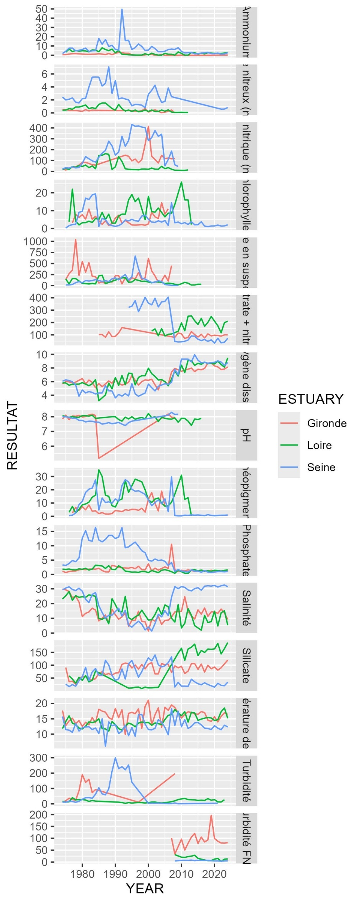

#### PCA

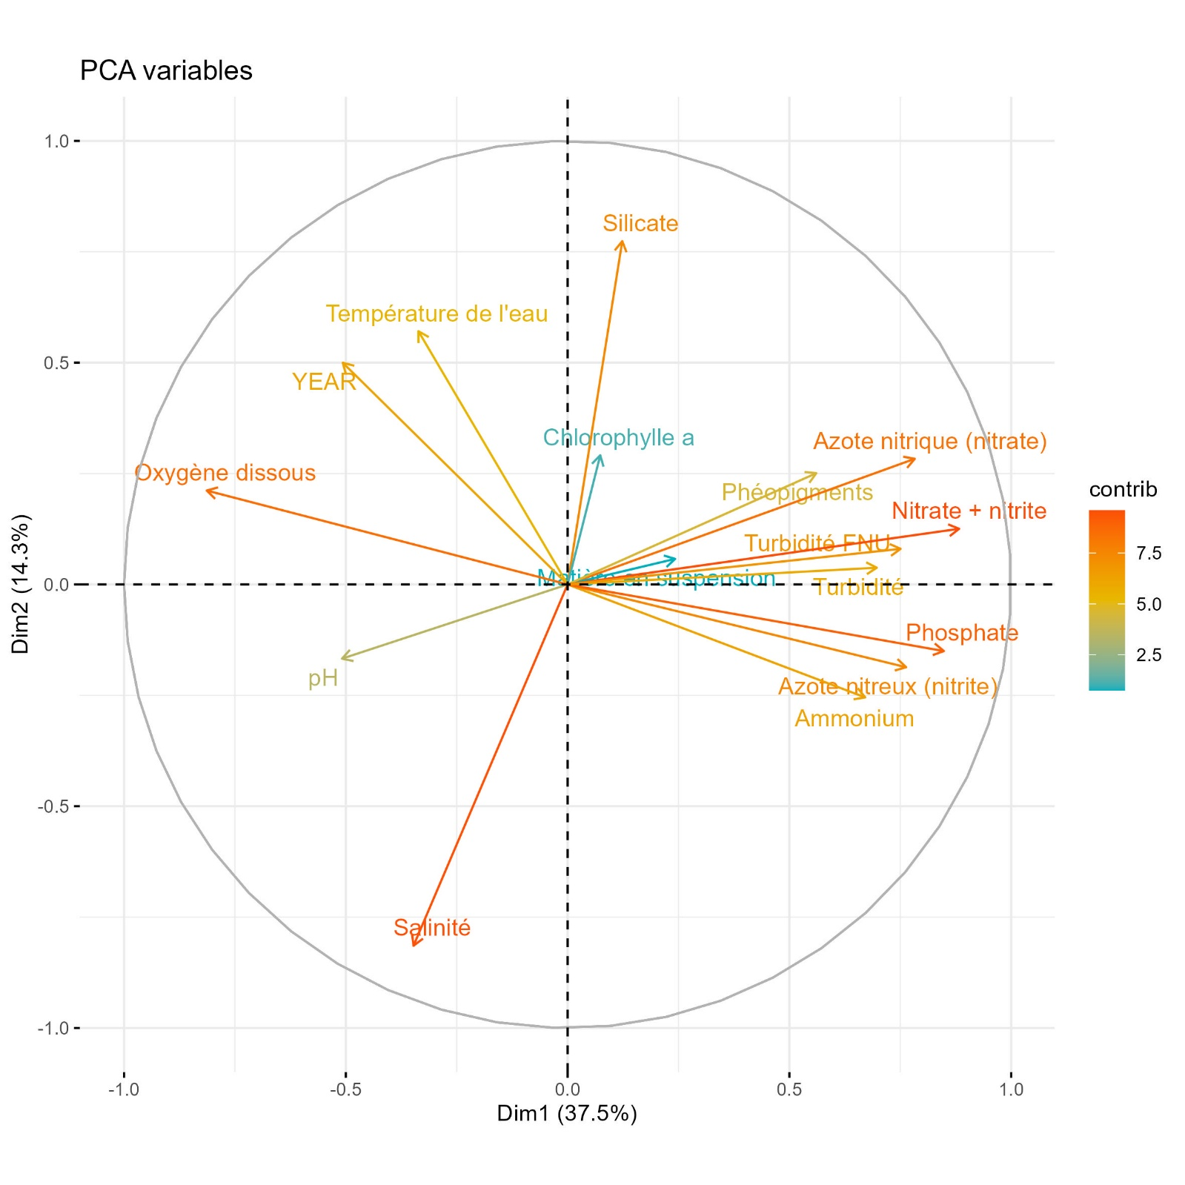

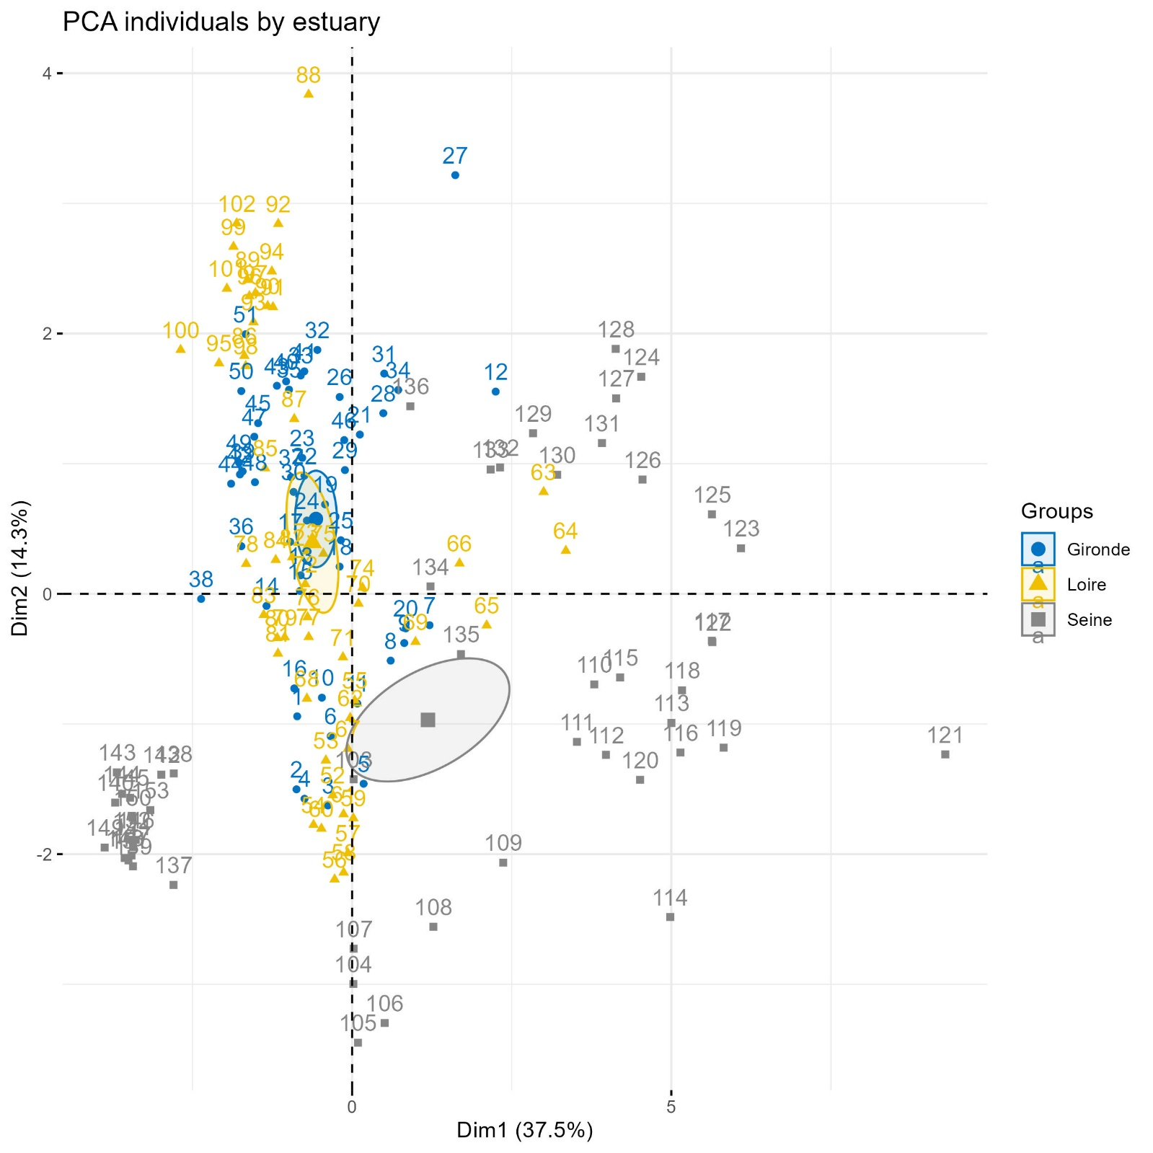

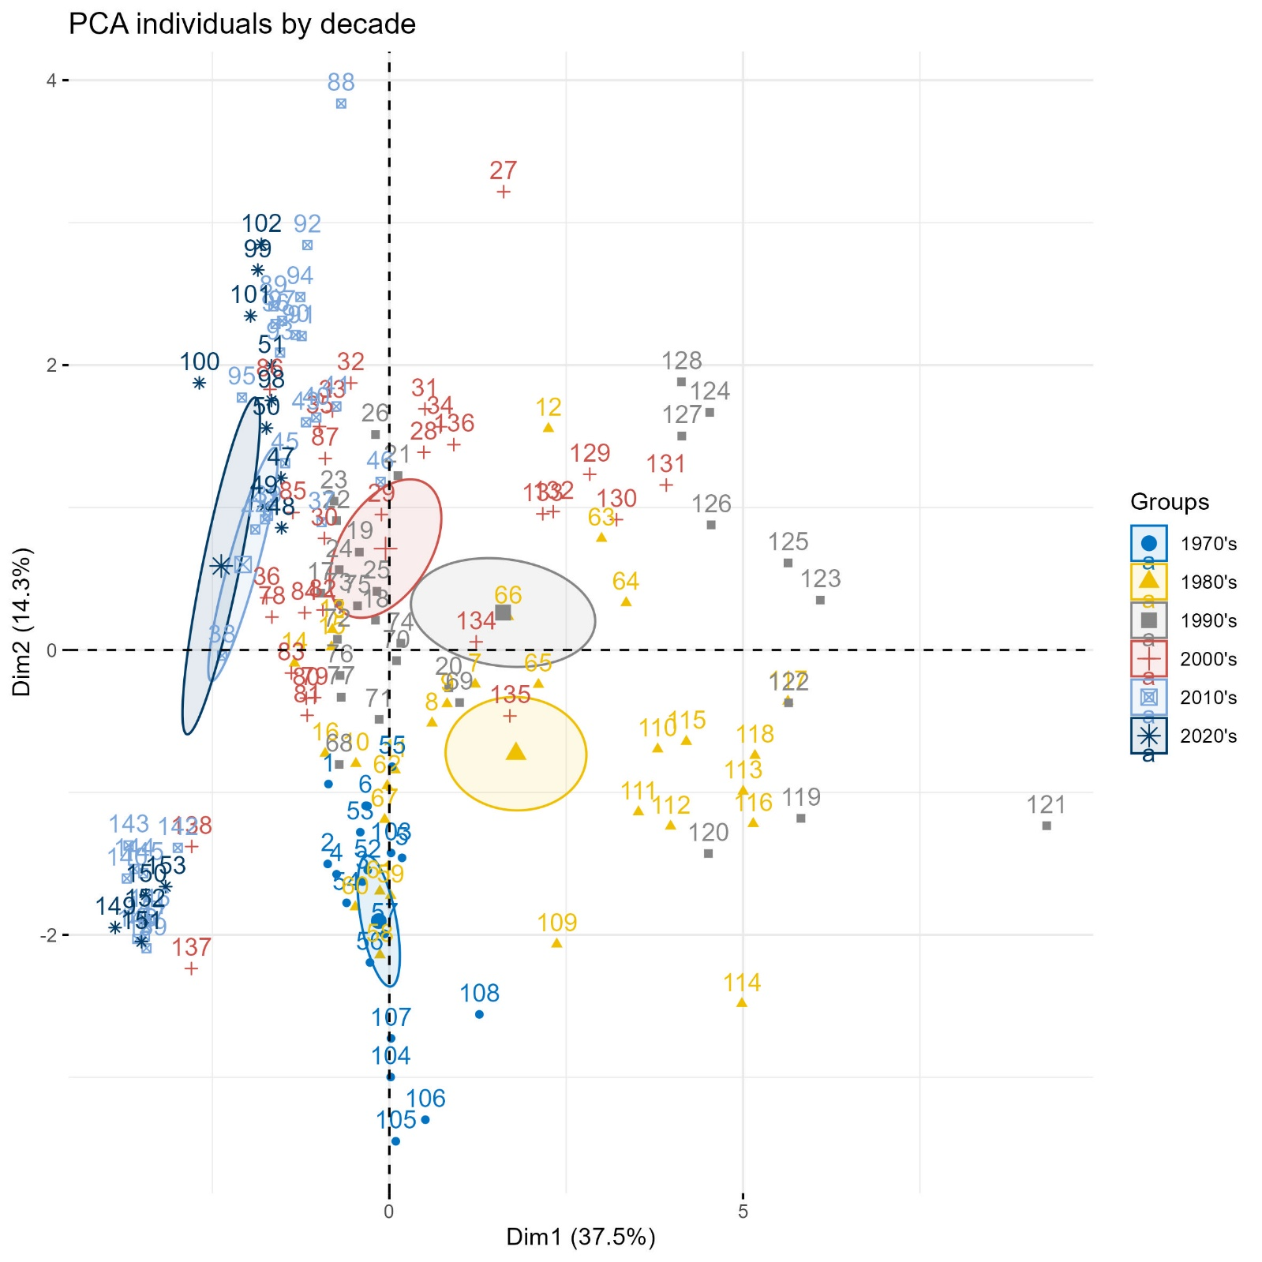

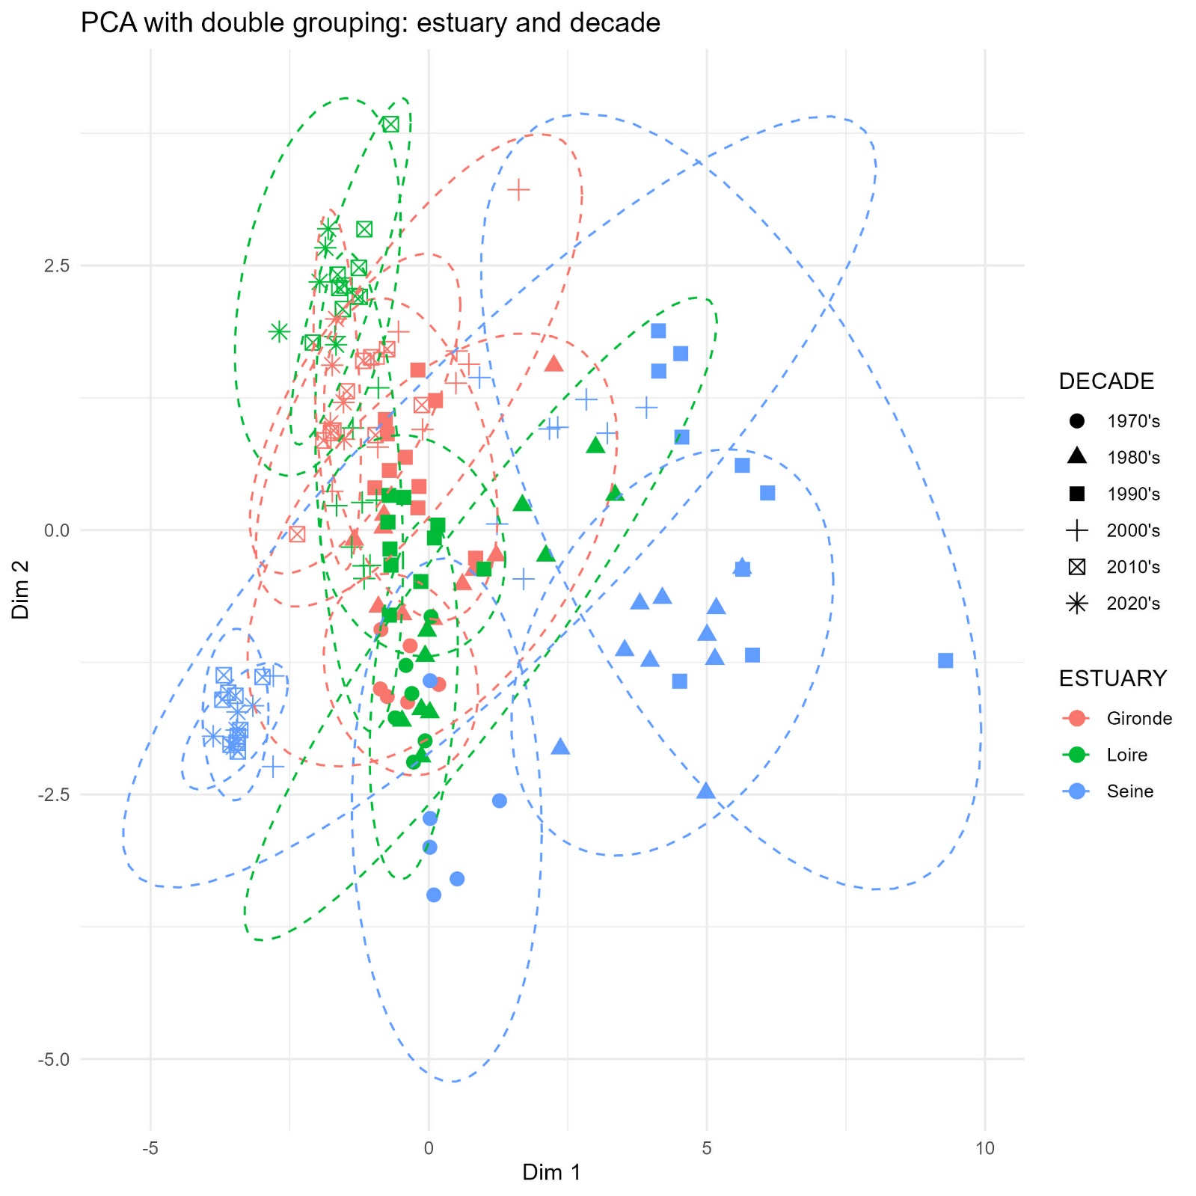

## Results

### Contamination

#### Metals

|  |  |
| --- | --- |
|  |  |
| Figure 1 – Time series of metals contamination for the Gironde, Loire and Seine estuaries from 1979 to 2024. Arrows indicate the last 15 years trends (Spearman’s test). Dashed horizontal lines are the current sanitary norm values when existing. | Figure 2 – Long term evolution of contamination for the Gironde, Loire and Seine estuaries expressed as percentage deviation to the sanitary norms when existing. First period: 1979-1983. Last period: 2020-2024. Arrows indicate the long-term trends (Kruskal-Wallis rank sum test). |

Time series of metal contamination since 1979 indicate that, across all estuaries, mercury remains consistently, during the 2020-2024 period, the least detected contaminant (0.025 µg/gww accross), followed by cadmium (0.230 µg/gww), lead (0.249 µg/gww), and copper (2.069 µg/gww).

Contamination levels are below their sanitary norms (OSPAR, 2023a) for each metal and estuary, at the exception of the contamination in cadmium for the Gironde estuary (2.5 fold). Globally, the Gironde is most contaminated estuary for metals and the Seine estuary is the least contaminated.

Indeed, results indicate that the Gironde estuary has historically been more contaminated with metals than the other estuaries, particularly with cadmium and copper, respectively a 28-fold and a 3-fold ratio compared to the Loire estuary, the least contaminated estuary, between 1979 and 1983. However, a long-term comparison between the first and last five years of monitoring (1979-1983 vs 2020-2024) shows a significant decrease in cadmium concentrations in all estuaries. This led to a decrease of cadmium concentration from 7.7 to 2.4 µg/gww in the Gironde estuary, although current levels remain higher than the sanitary norm value (1 µg/gww) and those observed in the Loire (0.2 µg/gww) and Seine (0.3 µg/gww) estuaries. The most recent trends (last 15 years) indicate a decrease of cadmium for all the estuaries, though not significant for the Seine and the Gironde estuary. Concerning copper, the gap between the Gironde estuary and the others is increasing with a long-term significant increase of concentrations while the other estuaries remained at the same levels. Thought, most recent trends indicate an increase of copper in all estuaries, significantly for the Loire estuary.

Mercury long-term and recent analysis show no significant trend.

Lead long-term and recent analysis show a significant decrease in the Loire estuary. No significant trends were found in the other estuaries, however results showed a decrease the Seine estuary and an increase in the Gironde estuary.

#### PCB indicators

* Globalement on observe une diminution à court et long terme, souvent significative, pour tous les estuaires et tous les PCB indicateurs
* Tous les estuaires sont, encore en 2024, au-dessus de la norme pour le CB118 (dioxine-like très toxique et bioaccumulable)
* L’estuaire de la Seine est plus contaminé en PCB que les autres estuaires et dépasse les normes environnementales de l’OSPAR pour tous les PCB de logKow moyen, CB101, CB118 et CB138 (supposés les plus bioaccumulables) mais les tendances à long terme et durant la dernière période montrent une diminution significative (sauf la diminution récente en CB180 qui n’est pas significative)
* La Gironde est le 2ème estuaire le plus contaminé mais ses niveaux sont proches de ceux en Seine

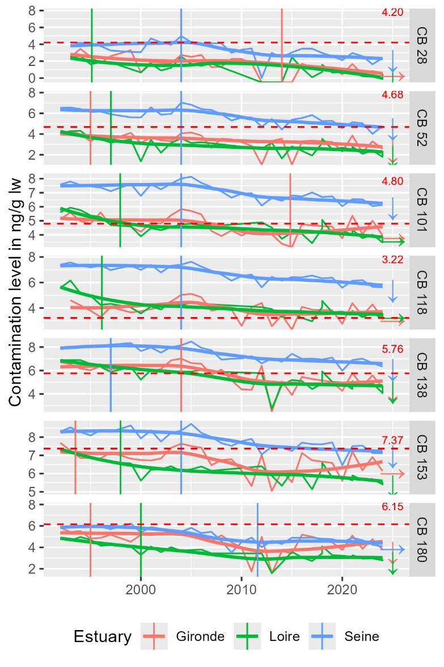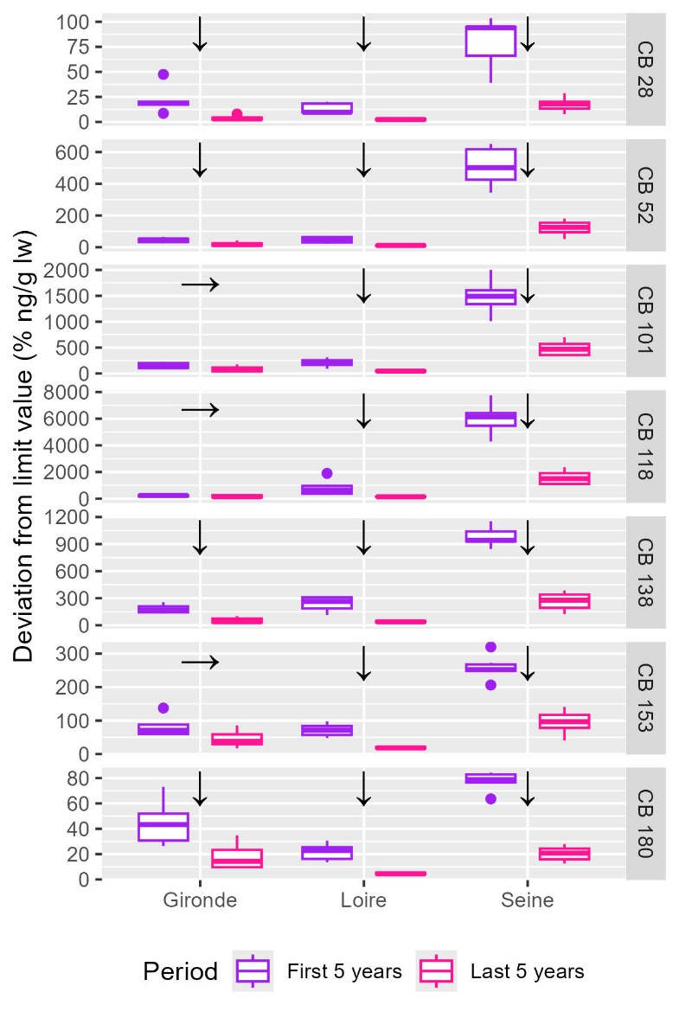

#### Dioxine and dioxine-like compounds

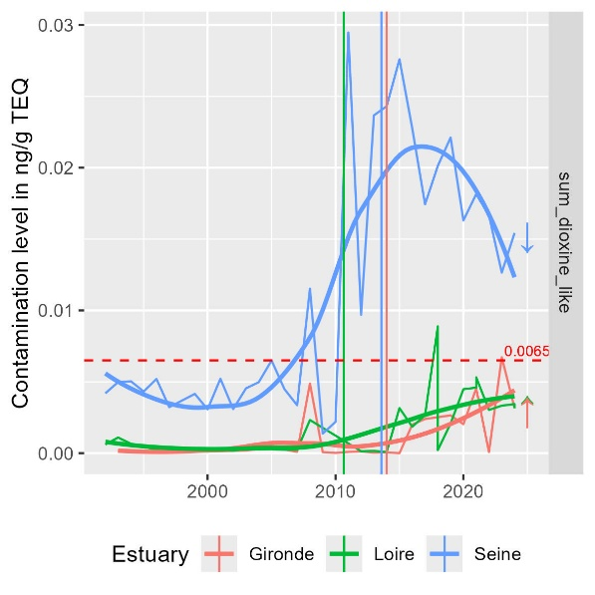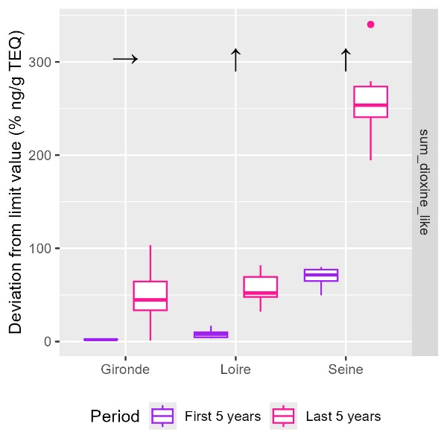

* Augmentation à long terme pour tous les estuaires, significative pour la Loire et la Seine
* Niveau beaucoup plus élevé en Seine, au-dessus de la norme de qualité environnementale d’un facteur 2.5
* Tendances récentes à l’augmentation significative, environ depuis 2005, en Gironde et en Loire
* Tendance récente à la diminution significative en Seine depuis 2015 après une forte augmentation entre 2005 et 2015

#### Organochlorine pesticides

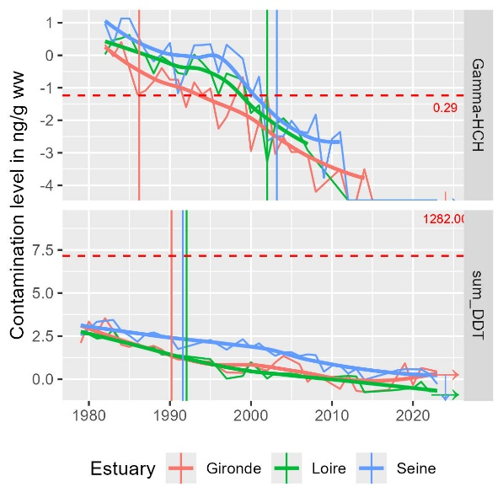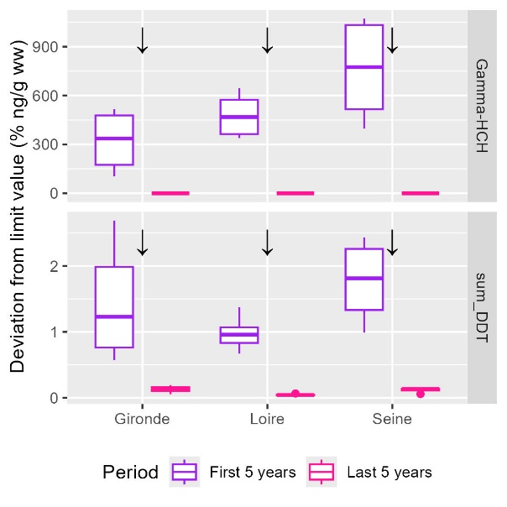

* Tendances à long terme significativement décroissantes pour tous les estuaires et pesticides
* Tous actuellement en dessous des normes environnementales, mais au dessus avant 1995-2000 pour le lindane pour tous les estuaires
* Tendance récente stable ou décroissante autour de zéro

#### Tributyltin cation

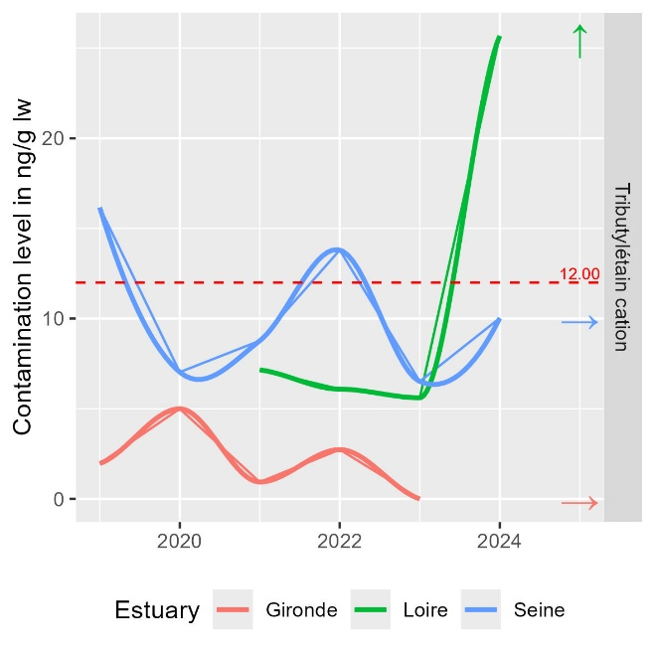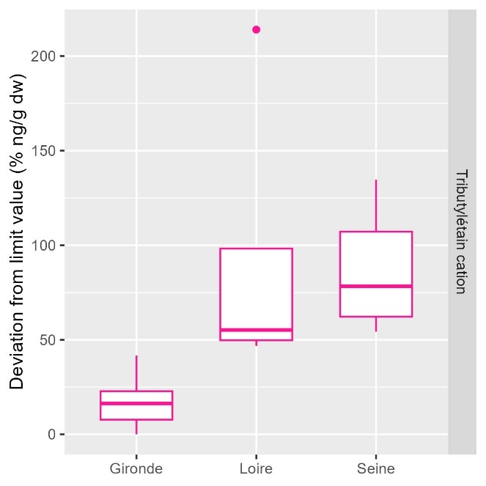

* Emergent, étude de la période récente seulement
* Un dépassement en 2024 en Loire avec une potentielle tendance à l’augmentation avec des dernières valeurs autour de 2.25 fois la norme (seulement 2 années de mesure)
* Des dépassements ponctuels en Seine avec des valeurs autour de 0.5 à 1.25 fois la norme
* Des niveaux faibles (0-0.5 fois la norme) et pas de tendance d’évolution en Gironde

#### Polycyclic aromatic hydrocarbon (PAH)

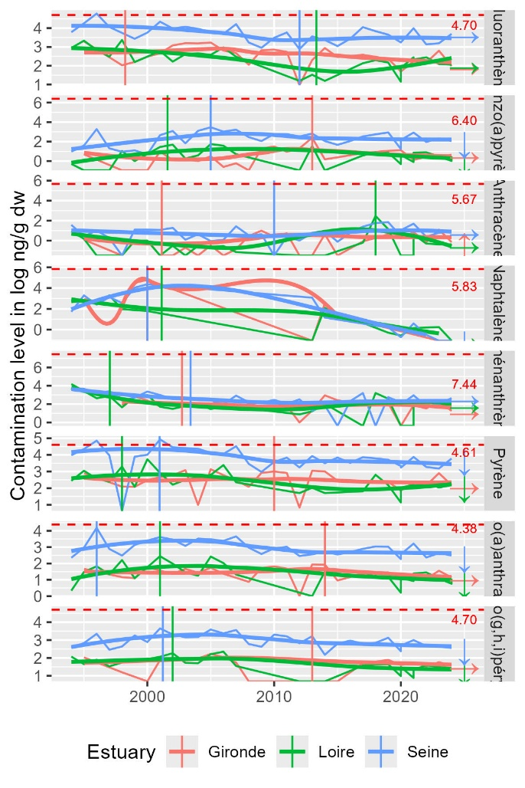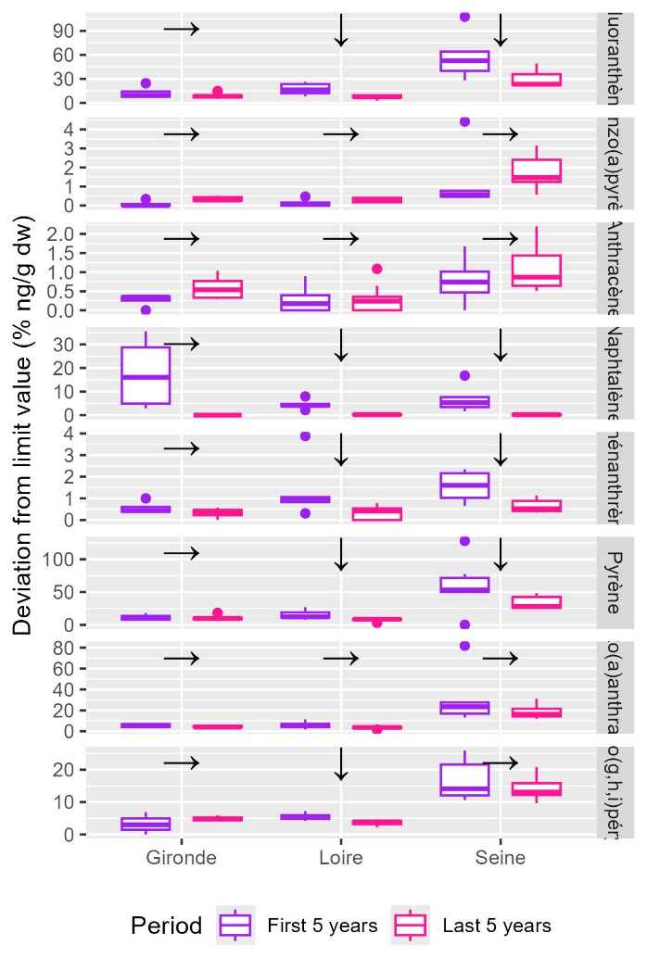

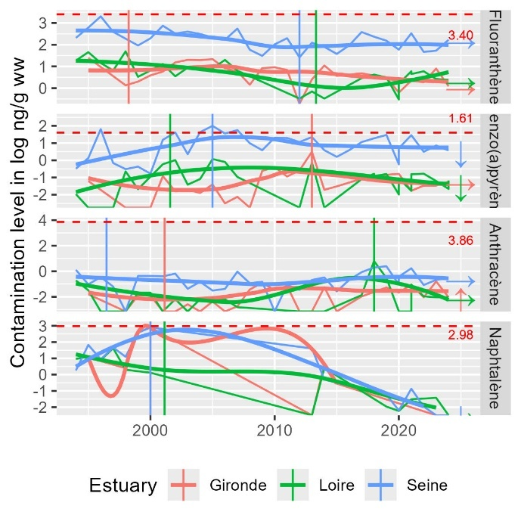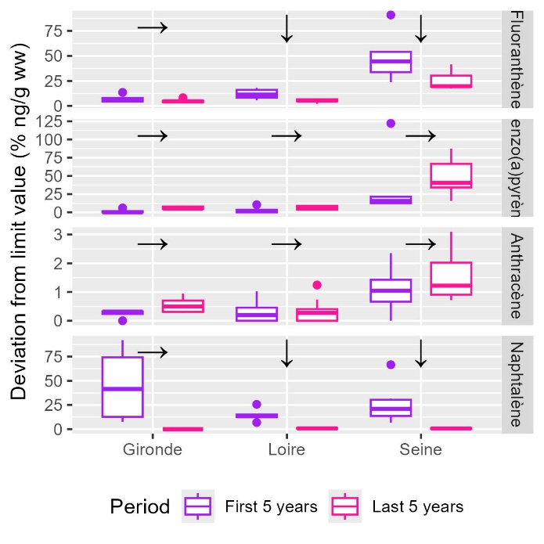

* Toujours en dessous des normes pour tous les estuaires
* Seine plus contaminée que les autres estuaires pour tous les PAH, niveaux similaires en Loire et Seine
* Tendances récentes et à long terme montrent une diminution significative ou une stagnation pour tous les contaminants et estuaires
* On observe une tendance significative à l’augmentation en Gironde en Anthracène mais pour des niveaux très faibles (de 0.05 à 0.2 fois la norme)

#### Brominated flame retardant

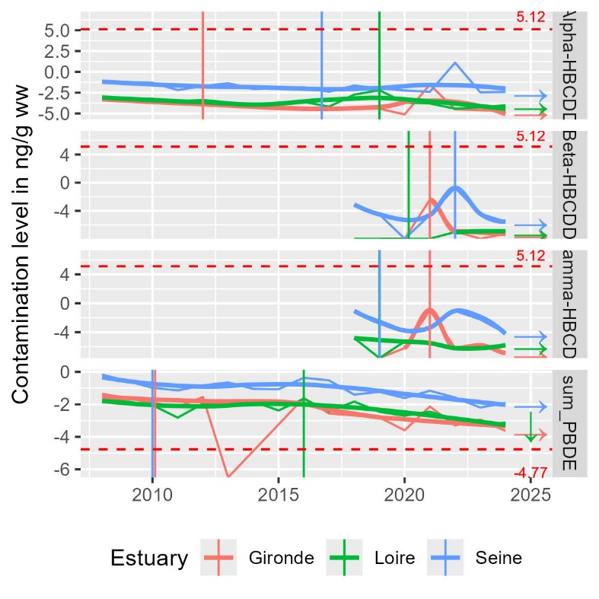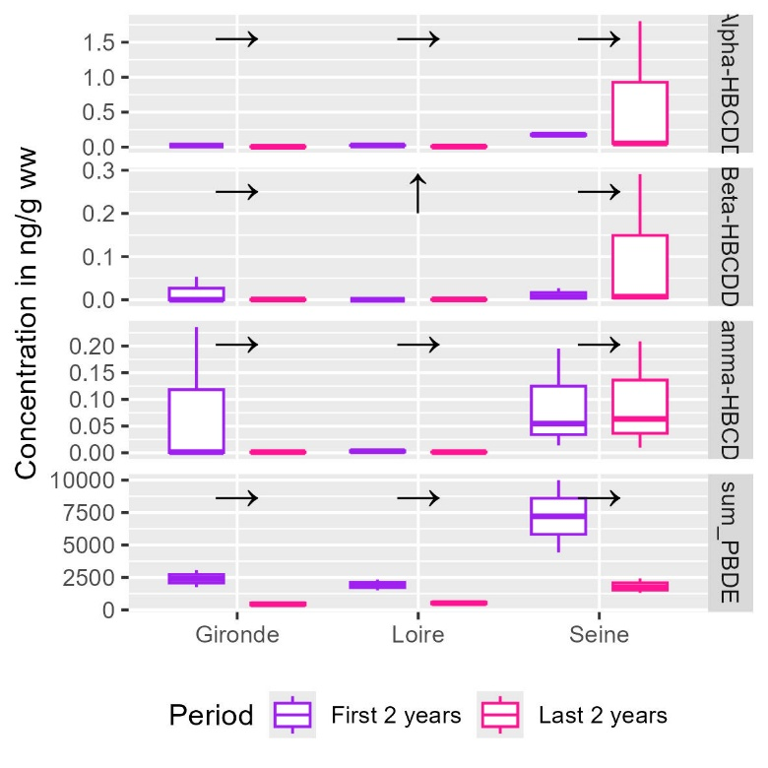

* Les retardateurs de flammes bromés ne sont suivis que depuis 2008 et les isomères beta et gamma de l’HBCDD ne sont suivis que depuis 2018. Les tendances à long terme portent donc sur des périodes de 2 ans
* Tous les isomères de HBCDD sont en dessous des normes environnementales et à des niveaux stables et très faibles (0 à 1.75 fois la norme) pour tous les estuaires. On n’observe pas de tendance d’évolution sauf une augmentation en Loire mais étant donné la courte période et les niveaux très faible on n’en tiendra pas compte
* Tous les estuaires sont bien au-dessus des normes environnementales pour les PBDE (4 et 5 fois la norme en Gironde et Loire respectivement, 17 fois la norme en Seine)

#### Perfluorinated compound: PFOS

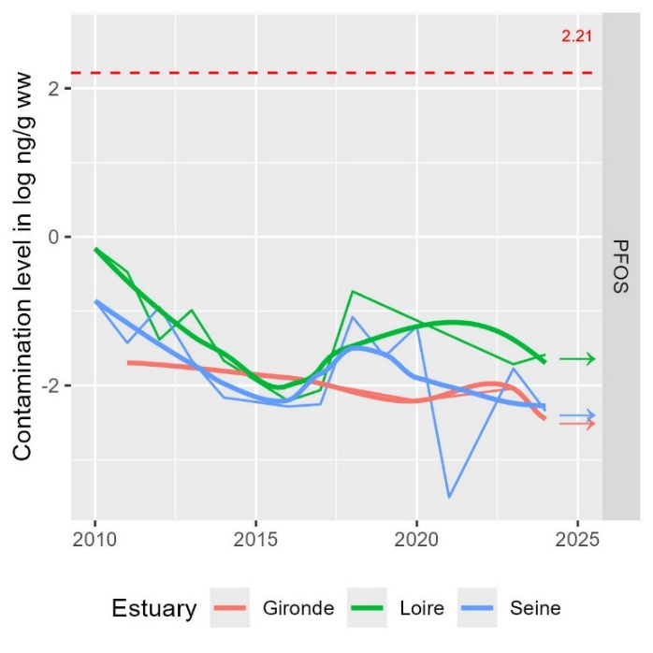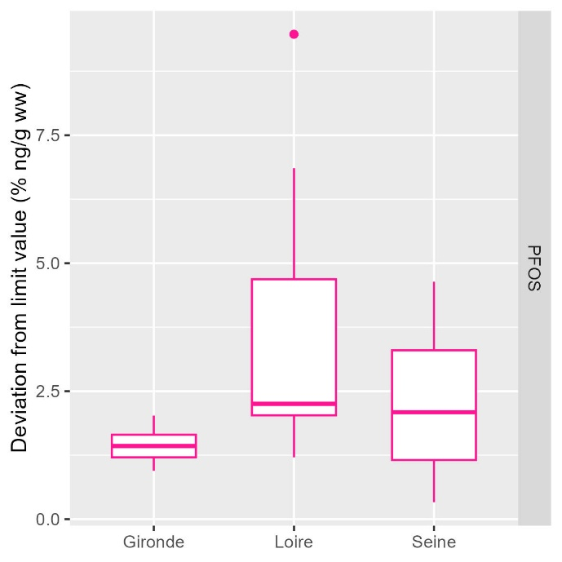

* Emergent, étude de la période récente seulement (depuis 2010)
* En dessous de la norme pour tous les estuaires (0.1 à 0.2 fois la norme)
* Pas de tendance d’évolution récente

### Benthic macrofauna

#### Campaign

|  |  |
| --- | --- |
|  |  |
|  | |

#### Species richness

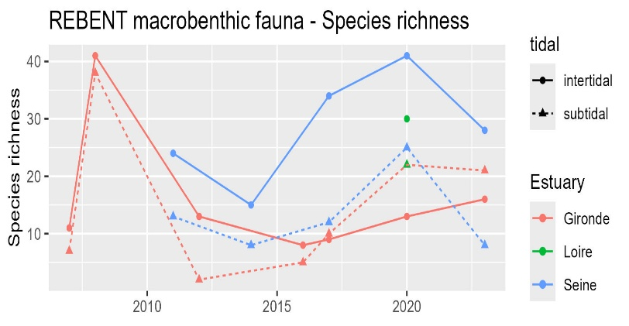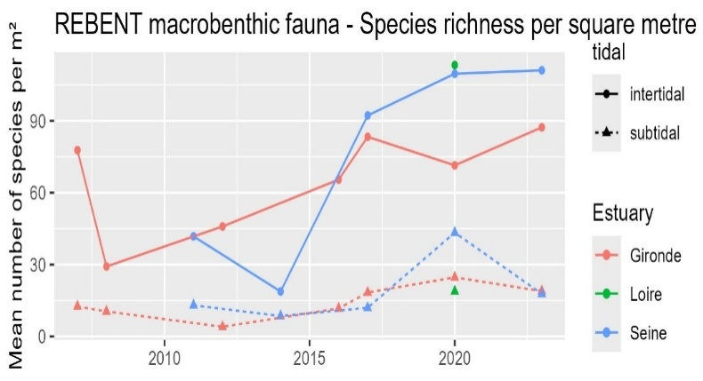

* Higher species richness in intertidal compared to subtidal areas
* Compared to the Gironde estuary, the Seine estuary exert higher species richness levels in both area since 2016
* The Loire estuary exert the lowest species richness in subtidal areas but the highest species richness in intertidal areas
* Species richness is increasing since 2007 in the Gironde and the Seine estuaries.

#### Taxonomic composition

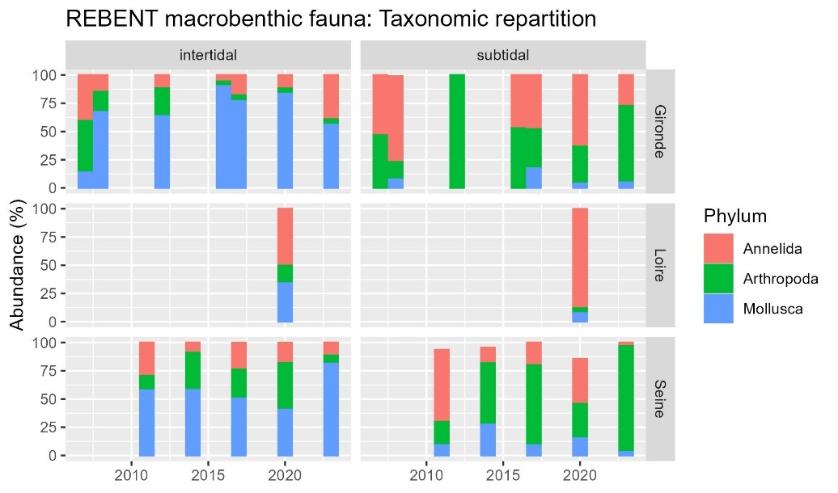

* Intertidal: highest abundance for molluscs for Gironde and Seine, annelids in Loire (Cordemay amphipodes ++ since 2020)
* Subtidal: highest abundance of arthropods, than annelids, for Gironde and Seine, annelids in Loire

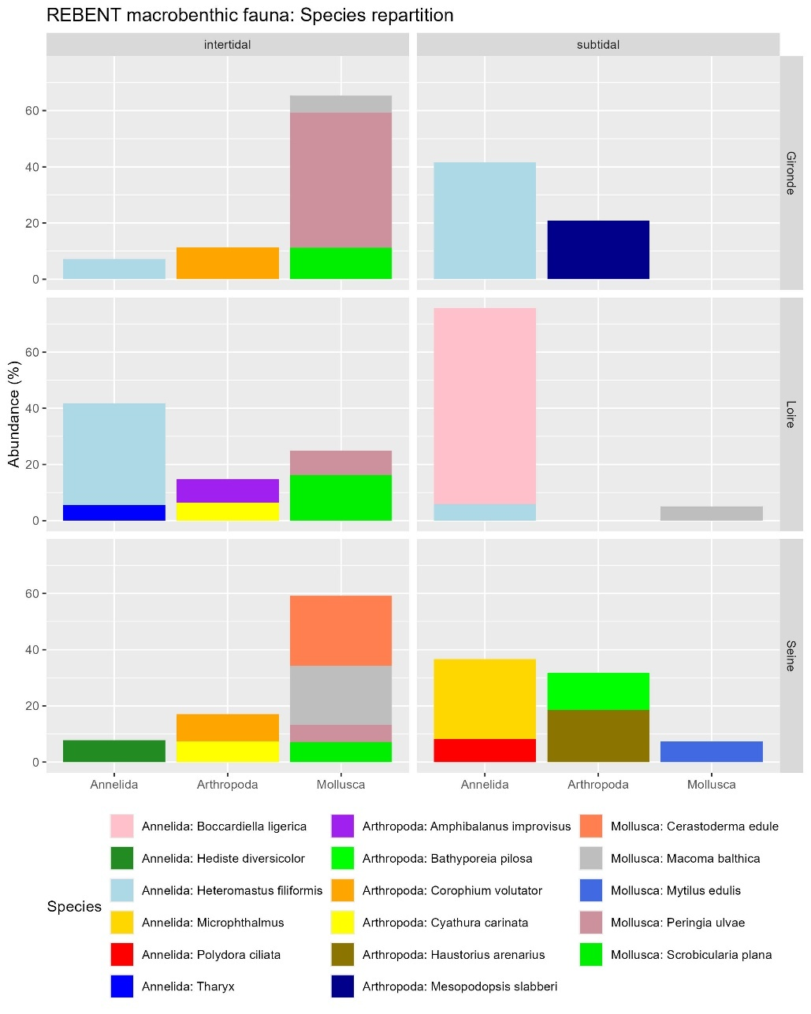

#### Abundance / Density

|  |  |
| --- | --- |
|  | * Much higher in intertidal areas than in subtidal areas * 3 fold higher in Loire intertidal areas than the highest densities in other estuaries and areas. * Seems to increase in both areas of the Seine and the Gironde estuary since 2007 |

#### Shannon index: biodiversity heterogenicity

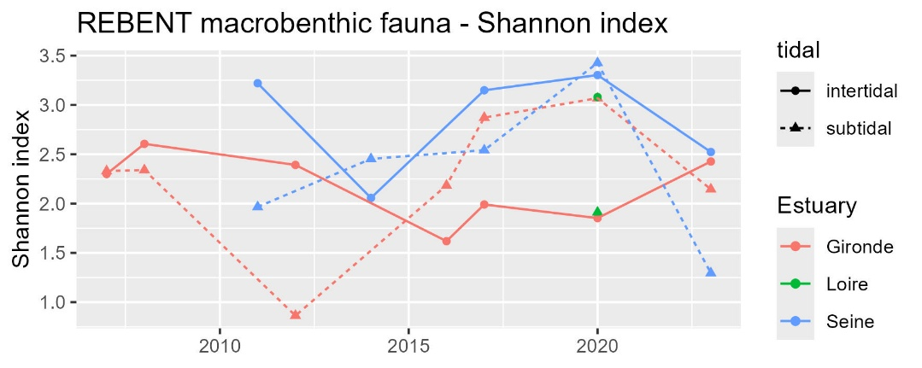

#### AMBI index: disturbances sensitivity (0 good – 7 bad)

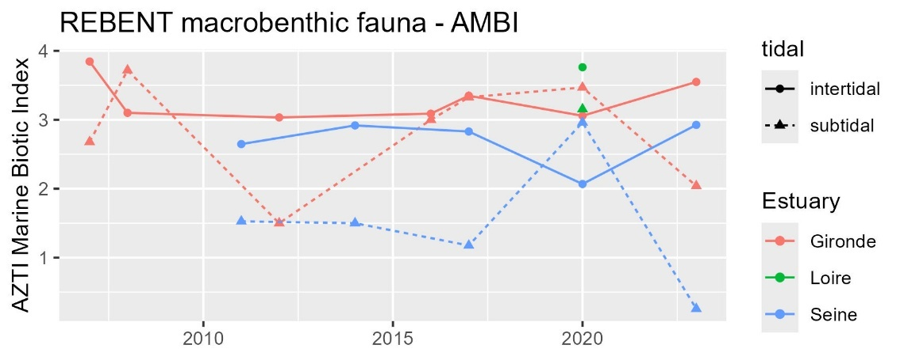

#### BEQI-Fr index: general quality

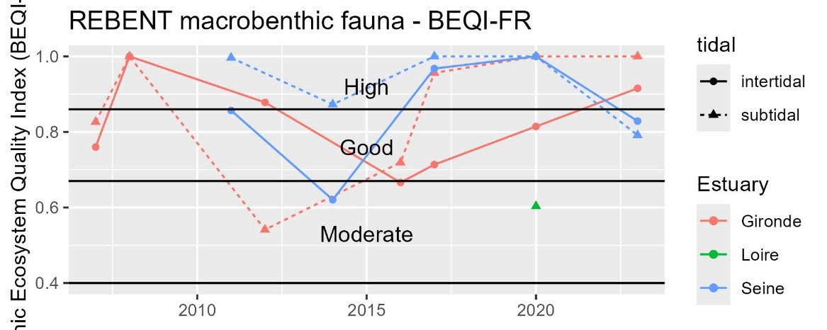

### Physico-chemical parameters

#### Primary production: pheopigment / chlorophyl a

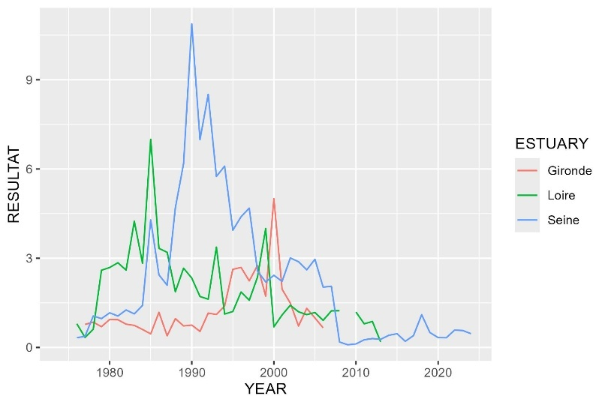

#### Nitrification cycle: Ammonium / nitrate+nitrite

|  |  |
| --- | --- |
|  | La somme calculée en Loire semble plus forte que celle mesurée dans Quadrige   * On garde quand même ? |
|  | * Reconstruction de la somme nitrate+nitrite à partir de la valeur max de « Nitrate + nitrite » ou « sumNO2NO3 » * Indicateur = Ammonium / (N02+NO3) * Ratio < 0.1 🡪 bonne nitrification * Ratio entre 0.1 et 1 🡪 conditions intermédiaires, dysfonctionnement saisonnier possible du cycle avec accumulation d’ammonium pouvant indiquer hypoxie, pollution organique, altération microbiologique |

## Supplementary

### Benthic habitats definition for BEQI-FR definition of reference states

#### EUNIS habitats characteristics

|  |  |  |  |  |  |  |  |  |
| --- | --- | --- | --- | --- | --- | --- | --- | --- |
| INTERTIDAL AREAS | | | | | | | | |
| EUNIS 2012 | Label | Taxon | Species density | Grain size | <63 µm | Organic matter | Salinity | Exposition (hydro) |
| MoSa A2.22 | Barren or amphipod dominated mobile sand shores. | Major: Amphipods  Potential : mobile crustaceans | Low | Medium size sand | No fine particules | Very low | High (mouth) | High |
| FiSa A2.23 | Polychaete or amphipod-dominated fine sand shores | Major: amphipods (haustorids maily Bathyporeia spp.) OR polychaetes (Eteone sp., Capitellidae) | High (+ highest diversity) | Fine sand | No fine particules | Very low | High | Moderate |
| MuSa A2.24 | Polychaete or bivalve-dominated muddy sand shores. | Major: Polychaetes (tolerant e.g. Spionidae or indicator of pollution Capitellidae)  OR bivalves (tellinids and semelids) Others: venerid bivalves + amphipods | Relatively high | Fine sand  (100 and 300 μm)  Few gravels | 3-33% | 1-3% | High but variable (mouth) |  |
| MEst A2.31 | Polychaete/bivalves-dominated mid estuarine mud shores. | Major sensitive species:  - Polychaetes (Nephtys hombergii, Hediste diversicolor, Heteromastus filiformis, Pygospio elegans and Eteone sp.. Peringia ulvae)  - Bivalves (Limecola balthica, Scrobicularia plana > Cerastoderma edule, Ruditapes spp., Abra tenuis) |  | Fine sandy-mud (20 and 150 μm) Few gravels | 15-75 % | 2-7% | Median subjected to freshwater influence |  |
| UEst A2.32 (upper MEst) | Polychaete/oligochaete-dominated upper estuarine mud shores. | - Polychetes (Nereids Allita succinea, Spionids Boccardiella sp.) and oligochetes (AMBI group III)  - also crustaceans (Corophium volutator, Cyathura carinata) - Disparition of sensitive species (e.g. S. plana)  - Apparition of invasive freshwater species (Corbicula fluminea)  - No other bivalves | Low | Muddy (40% of very fine sand 20 and 60 μm)  No gravel | 75 and 100 % | 4-7% | Low (subjected to strong freshwater influence) |  |

|  |  |  |  |  |  |  |  |  |
| --- | --- | --- | --- | --- | --- | --- | --- | --- |
| SUBTIDAL AREAS | | | | | | | | |
| EUNIS 2012 | Label | Taxon | Species density/diversity | Grain size | <63 µm | Organic matter | Salinity | Exposition (hydro) |
| SMuVS A5.32 | Sublittoral mud in variable salinity  (intertidal habitas of UEst) | * Oligochaetes * Polychaetes: Capitellidae (Heteromastus sp.), Spionidae, Nereidae, Phyllodocidae Some crustaceans: Corophium volutator, Cyathura carinata * Some molluscs : Scrobicularia plana, Limecola balthica (North Gironde estuary species) | Medium | Fine sand (20 and 200 μm)  Mud | 20-100% | 3-7% | variable |  |
| SSaVS A5.22 | Sublittoral sand in variable salinity | Sensitive species (AMBI group I) Amphipods: Eurydice spp., Bathyporeia spp. (highly mobile)  Polychaetes: Capitellidar, Ophelidae, Nephtyidae  Mysids shrimps : Gastrosaccus spp. | Low | Medium size sand (250-400 µm)  No gravel | <1-3 % | < 1 % | variable | Moderate |
| IMuSa A5.24 | Infralittoral muddy-sand (around MEst) | (AMBI group II and III)  Polychaetes: Magelona mirabilis, Spiophanes bombyx et Chaetozone setosa  Bivalves: Tellina fabula et Chamelea gallina | High | Muddy-sand  (70-200µm) | 5-20 % | 2-7 % | High | Marine bay |

#### Sediment grain size proportions

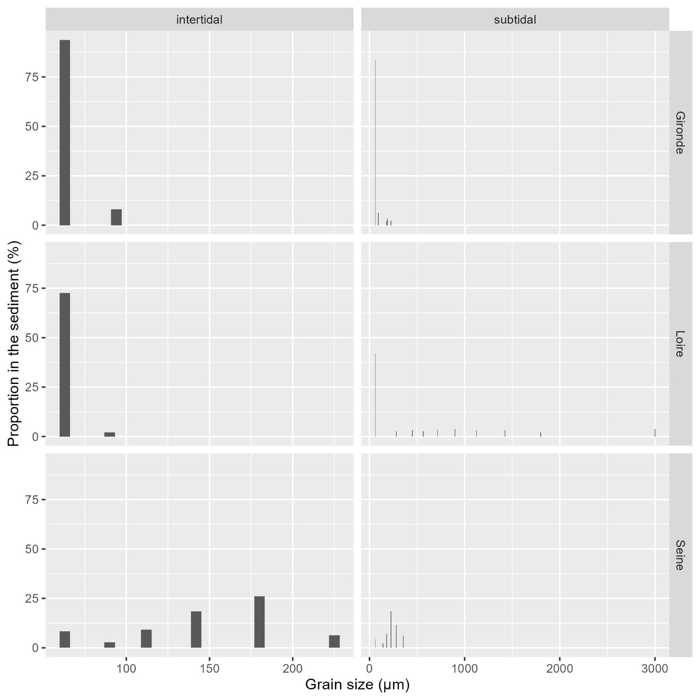

#### Benthic species composition

|  |  |  |  |  |  |  |
| --- | --- | --- | --- | --- | --- | --- |
| ESTUARY | tidal | phylum | class | order | species | abundance_prop |
| Gironde | intertidal | Arthropoda | Crustacea | Multicrustacea | Corophium volutator | 11,38123 |
| Gironde | intertidal | Mollusca | Bivalvia | Autobranchia | Scrobicularia plana | 11,25635 |
| Gironde | intertidal | Mollusca | Gastropoda | Caenogastropoda | Peringia ulvae | 48,12255 |
| Gironde | subtidal | Annelida | Polychaeta | Sedentaria | Heteromastus filiformis | 41,60935 |
| Gironde | subtidal | Arthropoda | Crustacea | Multicrustacea | Mesopodopsis slabberi | 20,83906 |
| Loire | intertidal | Annelida | Polychaeta | Sedentaria | Heteromastus filiformis | 36,23616 |
| Loire | intertidal | Mollusca | Bivalvia | Autobranchia | Scrobicularia plana | 16,21156 |
| Loire | subtidal | Annelida | Polychaeta | Sedentaria | Boccardiella ligerica | 69,68577 |
| Seine | intertidal | Mollusca | Bivalvia | Autobranchia | Cerastoderma edule | 24,90826 |
| Seine | intertidal | Mollusca | Bivalvia | Autobranchia | Macoma balthica | 20,91743 |
| Seine | subtidal | Annelida | Polychaeta | Errantia | Microphthalmus | 28,30508 |
| Seine | subtidal | Arthropoda | Crustacea | Multicrustacea | Haustorius arenarius | 18,47458 |
| Seine | subtidal | Arthropoda | Crustacea | Multicrustacea | Bathyporeia pilosa | 13,38983 |

## References

Blanchet, H. et al. (2025) Méthodologie pour la surveillance et l’évaluation du paramètre « Macro-invertébrés benthiques » dans les masses d’eau de transition estuariennes de la façade Manche- Atlantique –. Available at: https://archimer.ifremer.fr/doc/00887/99923/118418.pdf (Accessed: 9 July 2025).

Borja, A., Franco, J. and Pérez, V. (2000) ‘A Marine Biotic Index to Establish the Ecological Quality of Soft-Bottom Benthos Within European Estuarine and Coastal Environments’, Marine Pollution Bulletin, 40(12), pp. 1100–1114. Available at: https://doi.org/10.1016/S0025-326X(00)00061-8.

Borja, A. and Muxika, I. (2005) ‘Guidelines for the use of AMBI (AZTI’s Marine Biotic Index) in the assessment of the benthic ecological quality’, Marine Pollution Bulletin, 50(7), pp. 787–789. Available at: https://doi.org/10.1016/j.marpolbul.2005.04.040.

European Commission (2013) DIRECTIVE 2013/39/EU OF THE EUROPEAN PARLIAMENT AND OF THE COUNCIL of 12 August 2013 amending Directives 2000/60/EC and 2008/105/EC as regards priority substances in the field of water policy. Annex II ENVIRONMENTAL QUALITY STANDARDS FOR PRIORITY SUBSTANCES AND CERTAIN OTHER POLLUTANTS. Available at: https://eur-lex.europa.eu/eli/dir/2013/39/oj/eng (Accessed: 2 July 2025).

Fouet, M. et al. (2018) Sélection d’un indicateur DCE « faune benthique invertébrée » adapté aux estuaires. DOC00085633. Agence française pour la biodiversité - AFB, Université de Bordeaux Irstea, p. 77. Available at: https://professionnels.ofb.fr/fr/doc/selection-dun-indicateur-dce-faune-benthique-invertebree-adapte-aux-estuaires (Accessed: 8 July 2025).

Fouet, M., Blanchet, H. and Lepage, M. (2020) Intercalibration of biological elements for French transitional water bodies: benthic invertebrates. Water framework directive.

Ifremer (2018) Qualité du Milieu Marin Littoral. Bulletin de la surveillance 2017. Départements : Seine-Maritime, Eure, Calvados et Manche. Laboratoire Environnement Ressources d’Arcachon/Anglet. Ref. ODE/LERN/18-05. Ifremer, p. 175. Available at: https://archimer.ifremer.fr/doc/00457/56904/ (Accessed: 3 July 2025).

Ifremer (2021) 20 ans de suivi de la contamination chimique des eaux côtières méditerranéennes : Résultats et perspectives. Available at: https://archimer.ifremer.fr/doc/00673/78554/80744.pdf (Accessed: 2 July 2025).

Ifremer (2024) Qualité du Milieu Marin Littoral. Bulletin de la surveillance 2023. Départements de la Gironde, des Landes et des Pyrénées atlantiques. Laboratoire Environnement Ressources d’Arcachon/Anglet. Ref. ODE/COAST/LERAR/24.013. Ifremer, p. 194. Available at: https://archimer.ifremer.fr/doc/00924/103575/ (Accessed: 3 July 2025).

Ifremer (2025) Qualité du Milieu Marin Littoral. Bulletin de la surveillance 2024. Départements de la Loire Atlantique et Vendée (partie nord). Laboratoire Environnement Ressources MPL/NT. Ref. ODE/COAST/LER MPL/2025.06. Ifremer, p. 176. Available at: https://archimer.ifremer.fr/doc/00953/106531/ (Accessed: 3 July 2025).

Ineris (2022) Bilan annuel des travaux sur la thématique « substances dangereuses » dans le cadre de la convention OSPAR pour la protection et la préservation de l’Atlantique Nord-Est et ses ressources. Available at: https://www.ineris.fr/sites/ineris.fr/files/contribution/Documents/Suivi%20des%20travaux%20OSPAR%20%7B6%7Dsubstances%20dangereuses%7B6%7D%20v1.pdf.

Légifrance (2023) Article 3 de l’arrêté du 9 octobre 2023 modifiant l’arrêté du 25 janvier 2010 relatif aux méthodes et critères d’évaluation de l’état écologique, de l’état chimique et du potentiel écologique des eaux de surface pris en application des article R. 212-10, R. 212-11 et R. 212-18 du code de l’environnement. Available at: https://www.legifrance.gouv.fr/jorf/id/JORFTEXT000048347187 (Accessed: 2 July 2025).

legifrance.gouv (2023) Arrêté du 9 octobre 2023 modifiant l’arrêté du 25 janvier 2010 relatif aux méthodes et critères d’évaluation de l’état écologique, de l’état chimique et du potentiel écologique des eaux de surface pris en application des article R. 212-10, R. 212-11 et R. 212-18 du code de l’environnement - Légifrance. Available at: https://www.legifrance.gouv.fr/jorf/id/JORFSCTA000048347211?utm_source=chatgpt.com (Accessed: 17 May 2025).

van Loon, W.M.G.M. et al. (2015) ‘Application of the Benthic Ecosystem Quality Index 2 to benthos in Dutch transitional and coastal waters’, Journal of Sea Research, 103, pp. 1–13. Available at: https://doi.org/10.1016/j.seares.2015.05.002.

OSPAR (2023a) Status and trend for heavy metals (Mercury, Cadmium and Lead) in fish, shellfish and sediment. Available at: https://oap.ospar.org/en/ospar-assessments/quality-status-reports/qsr-2023/indicator-assessments/heavy-metals-biota-sediment/ (Accessed: 3 July 2025).

OSPAR (2023b) Status and Trends in the Concentrations of Polycyclic Aromatic Hydrocarbons (PAHs) in Shellfish and Sediment. Available at: https://oap.ospar.org/en/ospar-assessments/quality-status-reports/qsr-2023/indicator-assessments/pah-shellfish-sediment/ (Accessed: 3 July 2025).

OSPAR (2023c) Status and Trends in the Levels of Imposex in Marine Gastropods (TBT in Shellfish). Available at: https://oap.ospar.org/en/ospar-assessments/quality-status-reports/qsr-2023/indicator-assessments/tbt-shellfish/ (Accessed: 3 July 2025).

OSPAR (2023d) Status and Trends of Polychlorinated Biphenyls (PCB) in Fish, Shellfish and Sediment. Available at: https://oap.ospar.org/en/ospar-assessments/quality-status-reports/qsr-2023/indicator-assessments/pcb-biota-sediment/ (Accessed: 3 July 2025).